Individual Pathways
Activity 8.3
Analysing forces, energy and motion

- Over a 1-minute period of time, the position of a coach was plotted as she moved along the sideline during a netball game. Her position at 5-second intervals is shown in the table below. Assume that the coach started at the midline of the court.
Time (s) | Position (m)
0 | 0
5 | 3
10 | 6
15 | 6
20 | 6
25 | 7
30 | 8
35 | 9
40 | 10
45 | 10
50 | 8
55 | 4
60 | 0

- Use the values in the table to draw a position-time graph of the coach’s motion over the 1-minute interval.
- Use your graph from part (a) to help you draw a velocity-time graph of the coach’s motion for the interval.
- What quantity is represented by the gradient of your velocity-time graph? ……………………
- How does the velocity-time graph show that the coach’s displacement over the 1-minute interval is 0?
……………………………………………………………………………………………………………………………………………………………………………………………………
- Explain why the velocity time graph you have drawn is not a realistic representation of motion.
………………………………………………………………………………………………………………………………………………………………………………………………………………………………………………………………………………………………………

- The average polar bear runs at a top speed of 40 km/h. How far would it get at this speed if it ran for 10 minutes?
………………………………………………………………………………………………………………………………………………………………………………………………………………

- The ticker tape below shows the motion of a dynamics cart during an experiment. A ticker timer places 50 dots every second on the tape.

- What interval of time elapses between successive dots? …………………………………
- What period of time elapsed between points A and D? ………………………………
- In which intervals (A to B, B to C, or C to D) did the dynamics trolley:
- decelerate? Explain your answer. ………………………………………………………………………………………………………………………………………………………………………………………………
- remain at a constant speed? Explain your answer. ……………………………………………………………………………............................................................................................................................................................................

- Complete the following table.
Force | Mass | Acceleration
100 N |  | 18 km/h/s
 | 300 g | 4 m/s²
1.2 N | 2 kg

- A car is travelling down the highway at 90 km/h when a kangaroo bounces onto the road ahead. The driver takes 1.2 seconds to react and take his foot off the accelerator before braking hard.
- How far will the car travel during the time the driver is reacting? (This is called the reaction distance.)
…………………………………………………………………………………………………..
- The car’s brakes can slow the car at a rate of 6 m/s². How long will it take for the car to come to a complete stop?
……………………………………………………………………………………………………………………………………………………………………………………………………
- What force must be exerted by the brakes to stop the car if it has a mass of 1100 kg?
……………………………………………………………………………………………………………………………………………………………………………………………………
- The distance over which the car is brought to a stop by the brakes — the braking distance — is found using the equation: 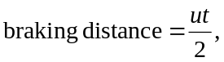
where u is the speed at which the car was travelling when braking commenced and t is the period of time taken for the car to stop. Use the equation to determine the car’s braking distance.
……………………………………………………………………………………………………………………………………………………………………………………………………
- The total stopping distance of the car is equal to the reaction distance added to the braking distance. Calculate the stopping distance of the car.
……………………………………………………………………………………………………………………………………………………………………………………………………
- Draw and label arrows on the diagram below to show the forces acting on the car during the deceleration.

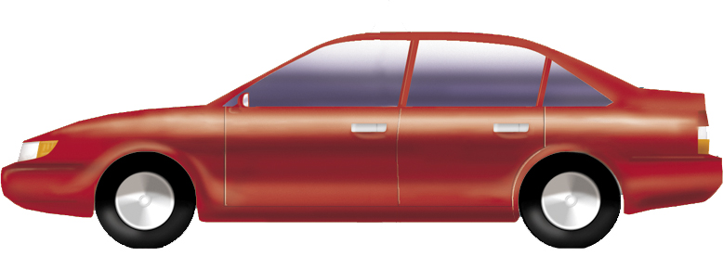

- Which two of the forces shown in your diagram are an example of an action-reaction pair?
…………………………………………………………………………………………………

- In which of the following cases is the most work done against gravity? Justify your answer.
- A 20 kg ball is dropped from a height of 3 metres
- A 60 kg student climbs up and down a 5-metre high flight of stairs
- A weightlifter holds a bar and weights with a mass of 150 kg at a height of 2.0 metres above the ground
- A 100 g chocolate bar is lifted up a distance of 40 cm from a tabletop.
……………………………………………………………………………………………………………………………………………………………………………………………………………………………………………………………………………………………………………………………………………………………………………………………………………………………………………………………………………………………………………

- A 90 kilogram skier catches a chairlift to the top of a 100-metre high hill then skies down the length of the 1200 metre slope.
- How much gravitational potential energy is gained by the skier as he is lifted to the top of the hill?
……………………………………………………………………………………………………………………………………………………………………………………………………
- As the skier comes down the slope, a frictional force of 40 N is exerted on the skis by the snow. How much kinetic energy does the skier have by the time he reaches the bottom of the slope?
………………………………………………………………………………………………………………………………………………………………………………………………………………………………………………………………………………………………………
- In what form has energy been transferred from the skier by the friction?
……………………………………………………………………………………………........
- Suggest at least two ways in which the skier can maximise the amount of kinetic energy that he retains at the bottom of the slope.
……………………………………………………………………………………………………………………………………………………………………………………………………

